Scenario 1: Student Academic Performance Dashboard

Code :
# Install ggplot2 if not already installed
# install.packages("ggplot2")

library(ggplot2)

student_data <- data.frame(
Student_ID = c(101,102,103,104,105,106,107,108),
Attendance = c(90,75,85,60,95,80,70,88),
Internal_Marks = c(88,70,82,60,95,78,68,90),
Department = c("CSE","AI","IT","ECE","CSE","AI","IT","ECE")
)

# Scatter Plot
ggplot(student_data,
aes(x = Attendance,
y = Internal_Marks,
color = Department)) +
geom_point(size = 4) +
labs(
title = "Student Academic Performance Dashboard",
x = "Attendance (%)",
y = "Internal Marks",
color = "Department"
) +
theme_minimal()

Output:
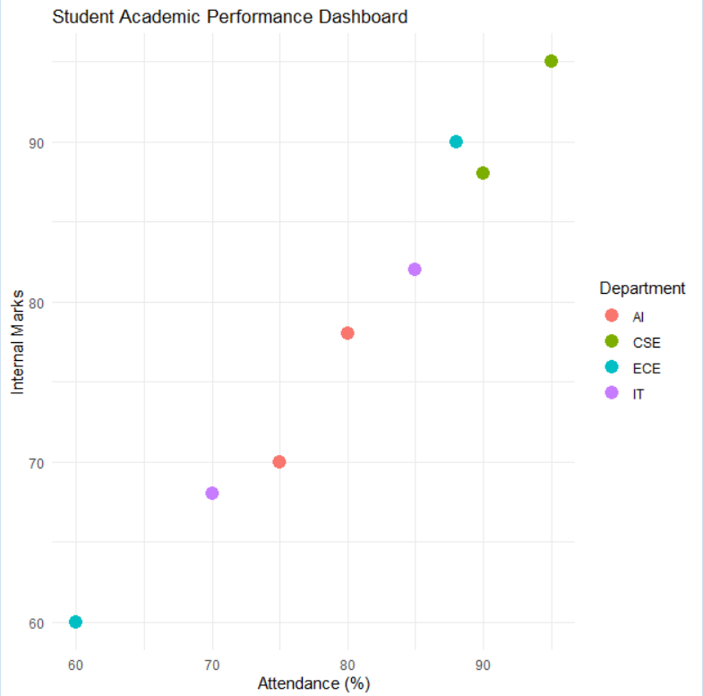

Scenario 2: Electric Vehicle Market Analysis
Code:
# Install ggplot2 if not installed
# install.packages("ggplot2")

library(ggplot2)

# Sample dataset
ev_data <- data.frame(
Vehicle_Model = c("Model A", "Model B", "Model C", "Model D",
"Model E", "Model F", "Model G", "Model H"),
Battery_Capacity = c(35, 45, 50, 60, 70, 80, 90, 100),
Price = c(12, 16, 18, 24, 28, 35, 42, 50), # Price in Lakhs
Driving_Range = c(220, 280, 300, 380, 420, 500, 550, 620),
Manufacturer = c("Tata", "MG", "Hyundai", "Mahindra",
"Tata", "BYD", "Hyundai", "BYD")
)

# Bubble Chart
ggplot(ev_data,
aes(x = Battery_Capacity,
y = Price,
size = Driving_Range,
color = Manufacturer)) +
geom_point(alpha = 0.7) +
labs(
title = "Electric Vehicle Market Analysis",
x = "Battery Capacity (kWh)",
y = "Price (Lakhs)",
size = "Driving Range (km)",
color = "Manufacturer"
) +
theme_minimal()

Output:
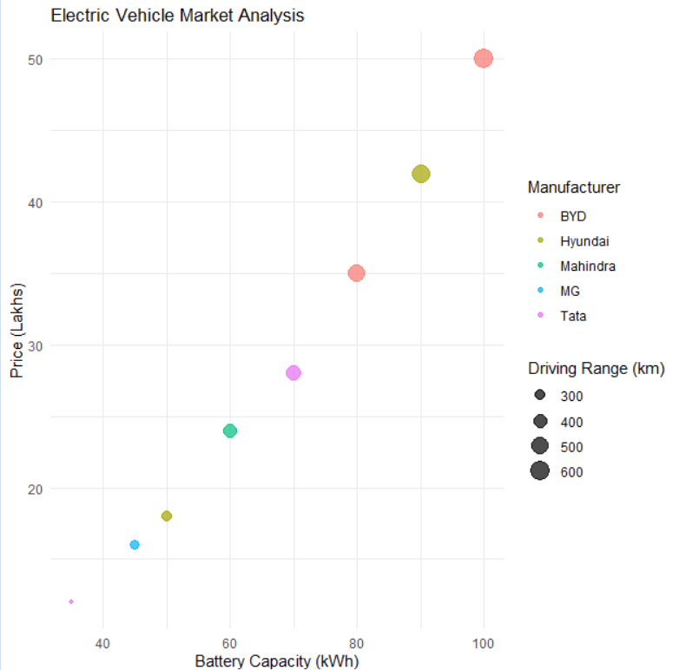

Scenario 3: Hospital Patient Admission Analysis

Code:
# Install ggplot2 if not installed
# install.packages("ggplot2")

library(ggplot2)

# Sample dataset
hospital_data <- data.frame(
Department = c("Cardiology", "Neurology", "Orthopedics", "Pediatrics", "Oncology"),
Number_of_Patients = c(120, 90, 150, 110, 80),
Average_Treatment_Cost = c(50000, 75000, 45000, 30000, 90000)
)

# Bar Chart
ggplot(hospital_data,
aes(x = Department,
y = Number_of_Patients,
fill = Department)) +
geom_bar(stat = "identity") +
geom_text(aes(label = Average_Treatment_Cost),
vjust = -0.5,
size = 4) +
labs(
title = "Hospital Patient Admission Analysis",
x = "Department",
y = "Number of Patients",
fill = "Department"
) +
theme_minimal()
Output:
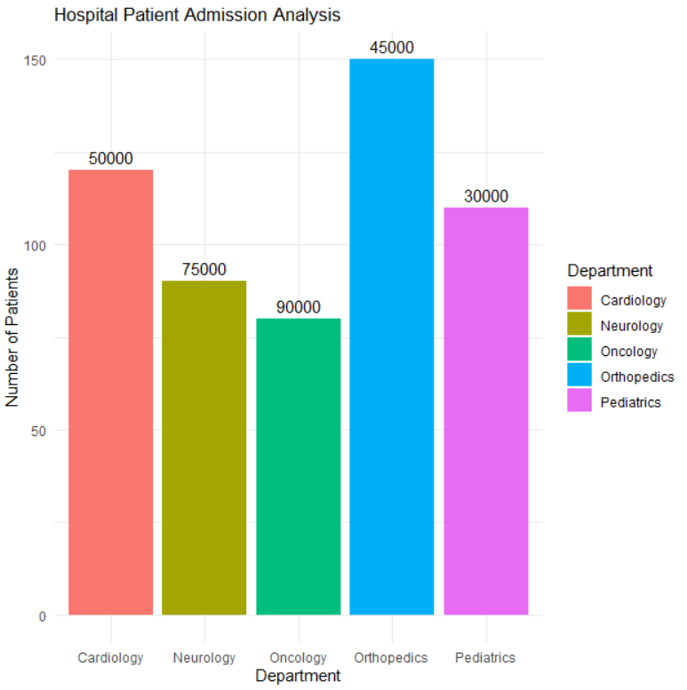

Scenario 4: Weather Monitoring System

Code:
# Install ggplot2 if not installed
# install.packages("ggplot2")

library(ggplot2)

# Sample dataset
weather_data <- data.frame(
Date = rep(as.Date(c("2025-07-01","2025-07-02","2025-07-03","2025-07-04","2025-07-05")), 3),
Temperature = c(
35, 36, 37, 36, 35, # Chennai
28, 29, 30, 31, 30, # Bengaluru
32, 33, 34, 33, 32 # Hyderabad
),
City = rep(c("Chennai", "Bengaluru", "Hyderabad"), each = 5)
)

# Line Chart
ggplot(weather_data,
aes(x = Date,
y = Temperature,
color = City,
linetype = City,
group = City)) +
geom_line(size = 1.2) +
labs(
title = "Weather Monitoring System",
x = "Date",
y = "Temperature (°C)",
color = "City",
linetype = "City"
) +
theme_minimal()

Output:
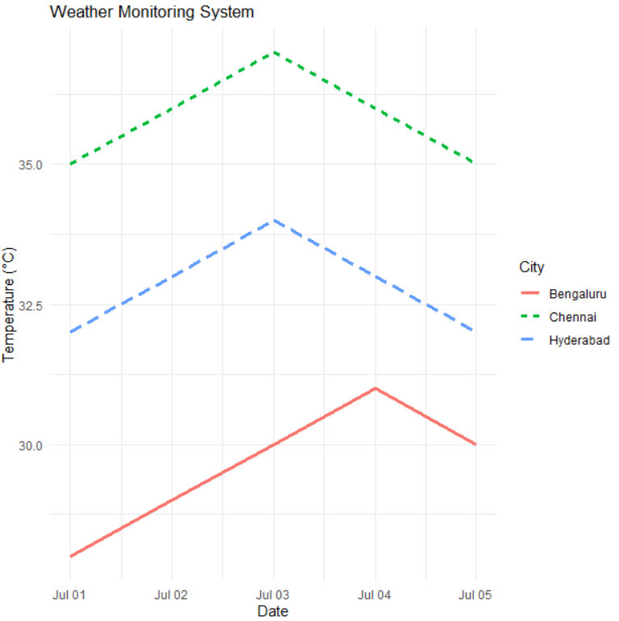

Scenario 5: Supermarket Sales Analysis

Code:
# Install ggplot2 if not installed
# install.packages("ggplot2")

library(ggplot2)

# Sample dataset
sales_data <- data.frame(
Month = rep("January", 9),
Product_Category = rep(c("Groceries", "Beverages", "Snacks"), each = 3),
Sales_Amount = c(50000, 45000, 48000,
30000, 32000, 31000,
20000, 22000, 21000),
Branch = rep(c("Branch A", "Branch B", "Branch C"), 3)
)

# Grouped Bar Chart
ggplot(sales_data,
aes(x = Product_Category,
y = Sales_Amount,
fill = Branch)) +
geom_bar(stat = "identity", position = "dodge") +
labs(
title = "Supermarket Sales Analysis",
x = "Product Category",
y = "Sales Amount",
fill = "Branch"
) +
theme_minimal()

Output:
